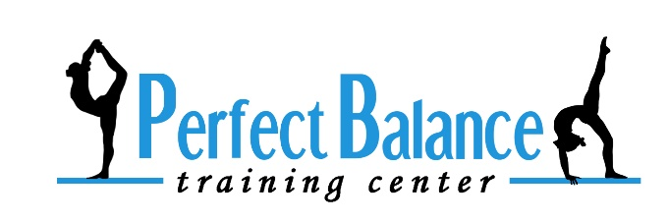

**8850 Monroe Road, Charlotte, NC 28212**

**980-299-8445**

**www.perfectbalancecharlotte.com**

**Single Event Registration, Waiver & Photo Release**

**Activity: ___________________________**

**REGISTRATION INFORMATION**

**Family Last Name: ___________________________________________________________**

**Parent’s Name: ________________________________________________________________**

**Contact Information:**

**Home Phone: _________________________ Cell: ____________________________Work: ______________________**

**Email: _________________________________________________________________________________________**

**Home Address: __________________________________________________________________________________**

**City: ______________________________________________ State: __________ Zip Code: ________________________**

**Child’s Name: ______________________________________________________ Date of Birth: _____________________________**

**Child’s Name: ______________________________________________________ Date of Birth: _____________________________**

**Child’s Name: ______________________________________________________ Date of Birth: _____________________________**

**Assumption of Risk**

**WARNING! Catastrophic injury, paralysis or even death can result from participation in this activity. In agreeing to my child’s participation and/or training in gymnastics, I hereby acknowledge my understanding that this activity involves greater than normal risk of injury.**

**Release of Liability**

**I agree, for myself or as my child’s parent/guardian to assume responsibility for all risks, cost, or losses sustained by me, my child or my child’s family in connection with participation in gymnastics classes, programs, lessons, competitions, birthday parties, open gyms, camps, field trips or any other activities connected with Perfect Balance Training Center or Patterson Properties. I hereby release and agree to hold harmless and to indemnify Perfect Balance Training Center employees, owners and volunteers from any claims, losses or expenses incurred on the behalf of me, my child or my child’s family.**

**Medical Emergencies**

**I hereby give my permission for Perfect Balance Training Center staff and/or an appropriate medical facility to take whatever emergency (first aid, disaster evacuation, etc.) measures as judged necessary for the care and protection of me or my child while under the supervision of Perfect Balance Training Center. In case of an emergency, I understand that I or my child will be transported to an appropriate medical facility by the local emergency unit for treatment if the local emergency resources deem it necessary. Transportation will be at my own expense. It is understood that in some medical situations, the Perfect Balance staff will need to contact the local emergency resource before the parent, physician and/or other actin on behalf o the parent or family can be reached.**

**Photo and Media Release**

**I understand that my child’s photograph or video may be taken during participation in any activity (class, team instruction, birthday party, open gym, special event, etc.) at Perfect Balance Training Center or at a function sanctioned by Perfect Balance Training Center. I hereby grant permission to Perfect Balance Training Center to use my child’s photograph or likeness in any publicity or promotional publications (e.g. website, social media, newspaper ads, bulletin boards, newsletters, programs, brochures, public broadcasting releases, etc.) and to allow videoing of my child for broadcast purposes.**

**I have read and agree to all of the information listed above.**

**Parent/Guardian Signature: ______________________________________________________Date: ________________________**